Machine Learning

Project

on

**Forest Fire Prediction System**

By Team 4

1) KALLEPALLY ANUSHA

2) BANDARI HONEY

3) VASIKARLA AKANKSHA

4) ASHWANI MANJULA

**Table of Contents**

1. INTRODUCTION

1.1 Overview

1.2 Purpose

2. LITERATURE SURVEY

2.1 Existing problem

2.2 Proposed solution

3. THEORITICAL ANALYSIS

3.1 Block Diagram

4. RESULT

5. ADVANTAGES & DISADVANTAGES

6. APPLICATIONS

7. FUTURE SCOPE

8. BIBILOGRAPHY

9.SOFTWARE REQUIREMENTS

10.HARDWARE REQUIREMENTS

1.INTRODUCTION:

1.1 Overview:

This project mainly focuses on the forest fire prediction, it alerts the observer or the maintaining team to take precaution that avoids fire exhaustion in the forest. Now-a-days due to many reasons we are losing our natural resources like forests so to avoid these, this system helps us to predict before the fire accident occurs. Mainly this system works on the levels of oxygen, Temperature and Humidity. If it reaches to a certain level then it will intimate us then we can make our precautions and to exhaust the fire.

1.2 Purpose:

To avoid forest fire accidents. To prevent the deforestation and increase greenery. The main purpose of the system is, it will always check the levels of oxygen, Temperature and Humidity. The system is already updated with the levels at which previously fire accidents with that analysis the system always works on this if these levels reaches the previous cases then it intimates us. So, it helps us to prevent from fire accidents.

2.LITERATURE SURVEY:

2.1 Existing problem:

Now-a-days forests are exhausted with fire accidents. Forest fires always start by one of two ways - naturally caused or human caused. Natural fires are generally started by lightning, with a very small percentage started by spontaneous combustion of dry fuel such as sawdust and leaves. On the other hand, human-caused fires can be due to any number of reasons. To avoid all these the device can be helpful. When the frequency of forest fires in a given area is high, the consequences can be devastating. ... Forest fires increase carbon dioxide levels in the atmosphere, contributing to the greenhouse effect and climate change. In addition, ashes destroy much of the nutrients and erode the soil, causing flooding and landslides.

2.2 Proposed Solution:

To the existing problem we came up with a solution that a device with precious fire accident cases which mainly focuses on the levels of the oxygen, Humidity and Temperature. If at any cost the same situation occurs then the device also works on that and detect the case and intimate us then we can take precautions before and we can save our forests.

3. THEORITICAL ANALYSIS:

3.1 Block Diagram

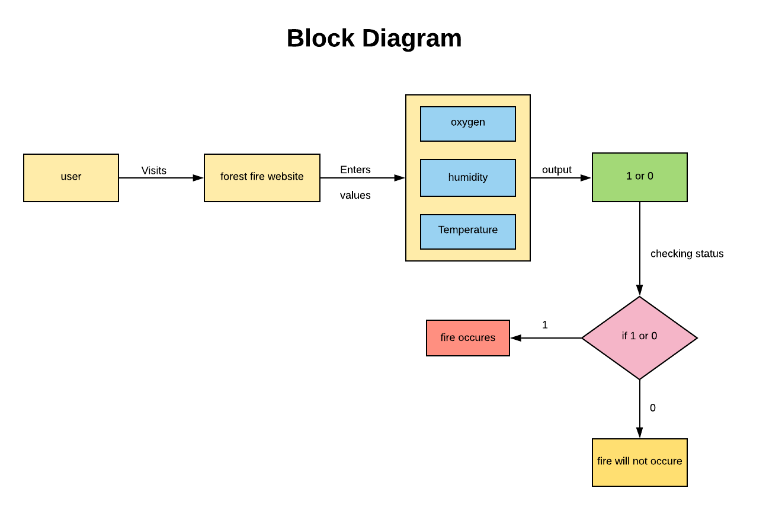

4.RESULT:

This device results to a forest fire exhaustion. If the oxygen, Temperature and Humidity levels matches with previous cases the it detects and inform to make precautions earlier. So, it helps to save our environment.

5. ADVANTAGES & DISADVANTAGES:

5.1 Advantages:

Within less time we can check whether the forest area will be affected with fire or not. And helps to take required measures in case of probability of fire occurred is 1.

5.2 Disadvantages:

If the system gets breakdown then sensors in it stop working and then the intimation it gives will not be accurate. Then the forest team or fire team cannot stop the fire.

6. APPLICATIONS:

The similar system is promising applications in forest fires can make a real-time monitoring and detection. This type of systems can also be useful in water tanks to know the levels of the water with different sensors and previous analysis.

7. FUTURE SCOPE:

Our project will have a scope in future as it will provide an approach for predicting fire occurrence. As now a days we can see availability of network everywhere.so by visiting our model website they can easily enter the required values with in no time.so as our model save peoples time and even forests from fire.

8. BIBILOGRAPHY:

Bibliographies on chaparral and the Fire Ecology of other Mediterranean Systems (Keeley) 1988. (California water resources centre report #69)

· Effects of Fire on forests: A bibliography (US forest service library) 1938 (Docs A 13.2 F51/25) Includes 605 references arranged by subject.

· Fire: A summary of literature in the united states from the Mid-1920s to 1966 (Docs A 13.2 F51/25) Includes 823 references categorized by broad topic.

· Forest fire research in California: An Annotated bibliography, 1923-1961 (Wilson & Nilsson) 1962 (pacific southwest Forest and range Experiment station Miscellaneous paper No.75) (Docs A 13.62/9:75)

9.SOFTWARE REQUIREMENTS:

Operating System: Windows 7, Windows 8, (or higher versions)

Language: Python 3.5 and other libraries likes NumPy, pandas, matplotlib, seaborn and scikit learn.

Mozilla Firefox (or any browser)

10.HARDWARE REQUIREMENTS:

Processor: core i3, i4 or higher

RAM: 2GB/4GB RAM and higher

Hard disk: 40GB and higher